THE TRAFFIC LAW FIRM

HOME PAGE
SIX OPTIONS ENG & SPANISH Button:
(1) Home
(2) Practice Areas (with Drop Box): Civil Traffic Infractions
Criminal Traffic and Crime Cases
Civil and Commercial Litigation
(3) About Us (with Drop Box): Lizette P. Benitez
Leo Benitez
(4) Reviews/Testimonials
(5) Contact Details
(6) Submit Citation

Home Our Services About Us THE TRAFFIC LAW FIRM Reviews/Testimonials Contact Us Hire Us
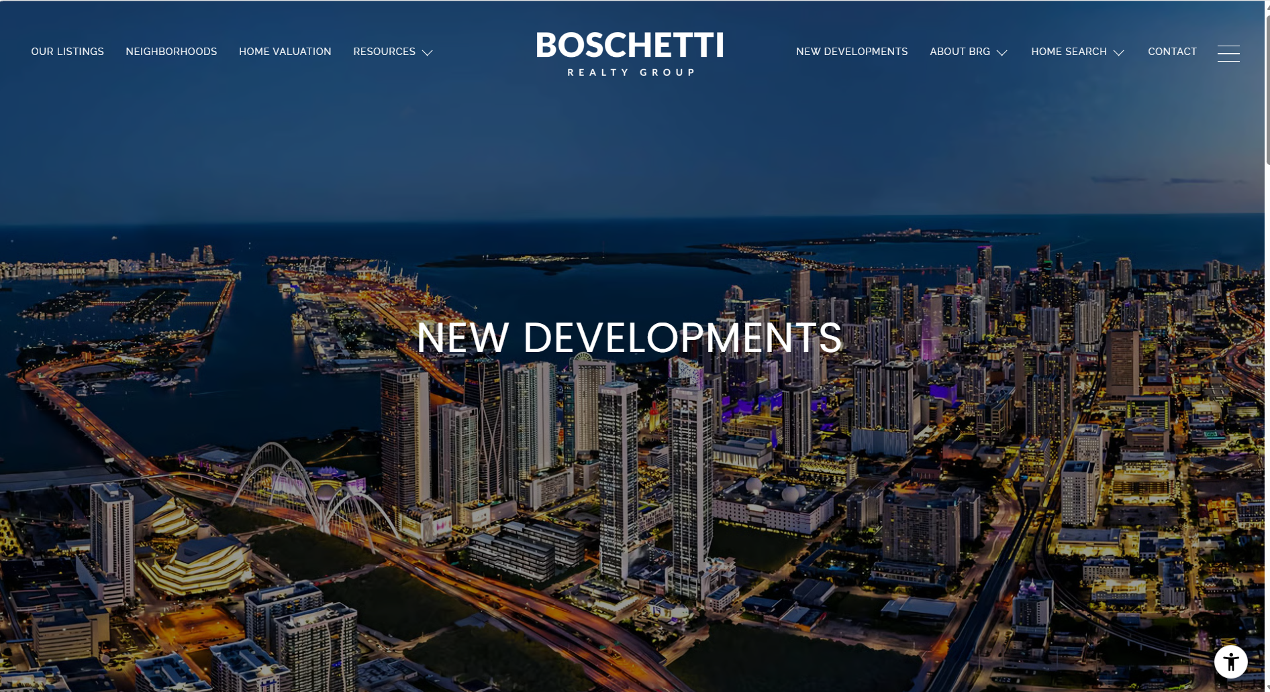
Please refer to the Boschetti Real Estate Website: See Residential Areas in Florida | Boschetti Realty Group

ACTIVE VIDEO OF CITY AND THE TRAFFIC LAW FIRM name in the middle, like above
THE ENGLISH AND SPANISH BUTTON SHOULD BE ON THE TOP RIGHT CORNER

The LOGO AND INITIALS (interactive with road swope) can go on the other 5 option pages that don’t have an active photo.
PRACTICE AREAS
DROP BOX- CIVIL TRAFFIC INFRACTIONS
CRIMINAL TRAFFIC AND CRIME CASES
CIVIL AND COMMERCIAL LITIGATION

For the literature on these 3 specialties, I want to refer to my old website to see what I wrote and make edit as needed. Otherwise, I will come up with something to write.

STILL PHOTO RELATED TO TRAFFIC STOP AND IN THE MIDDLE TLF LOGO


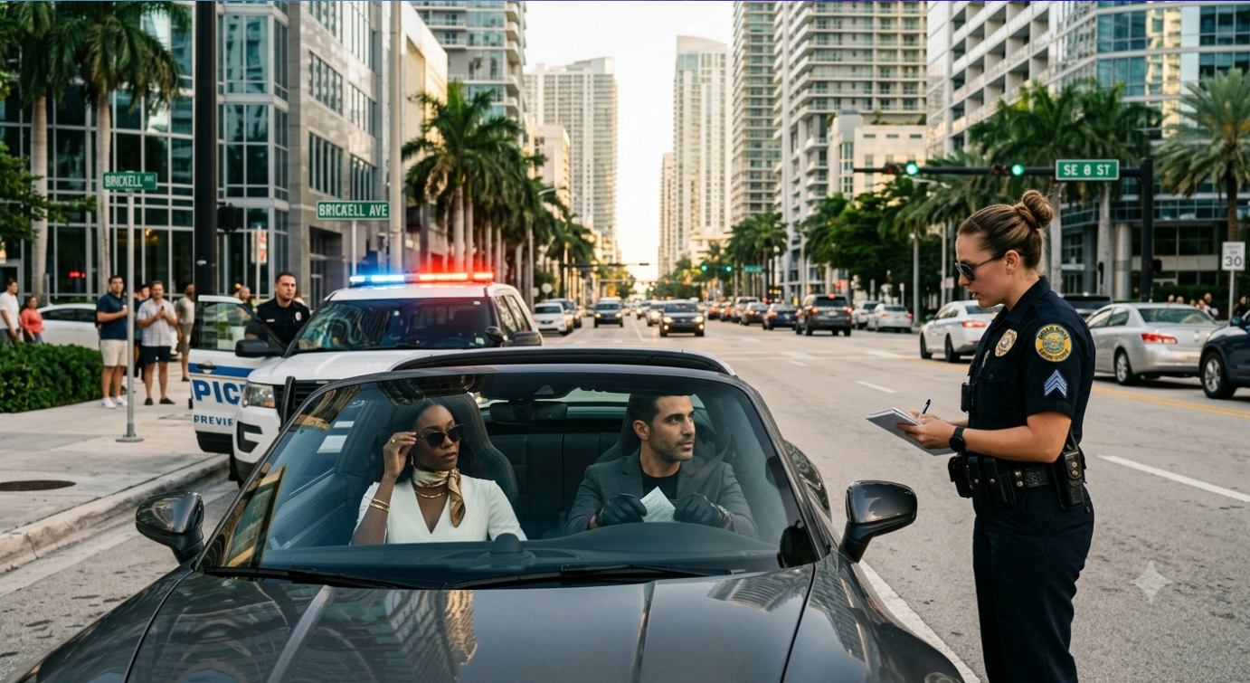
Below is a sample logo. It’s 3 dimensional. I couldn’t find the link sent by your graphic design artist in Chile. Sorry I forgot her name. She told me to pick colors for the logo and the name with the swope. Here’s an example in blue, white/grey and gold. It is three dimensional and it stands out. It doesn’t have to be this particular one, and the logo can be smaller. I don’t remember what logo she showed me. Please send me her link so I can see her designs.

ABOUT US

MEET OUR ATTORNIES Drop Box- Lizette Benitez
Leo Benitez


I would like a photo of Leo and I in this option. Our logo can go on the far-left hand corner, where this office has theirs. And where they have $1 Billion, we can add MEET OUR ATTORNEYS. The drop box can go on the far-right top corner. Underneath the photo we can write about TLF. The blue background is nice. Suggestions??

I want to refer to my old website to see what I wrote about The Traffic Law Firm and make edits as needed. Otherwise, I will come up with something to write. Please send it to me. You guys were able to find it and make it work.

The Traffic Law Firm opened its doors over thirty years ago……….

When you click on “Meet our Attorneys” it takes you to this page with both our pictures. You then click on the photo of the atty you want to read about.

Please refer to the Boschetti Real Estate Website: See Residential Areas in Florida | Boschetti Realty Group
CLICK ON EITHER ATTORNEY TO GET THEIR BACKGROUND ATTORNEY (Lizette or Leo)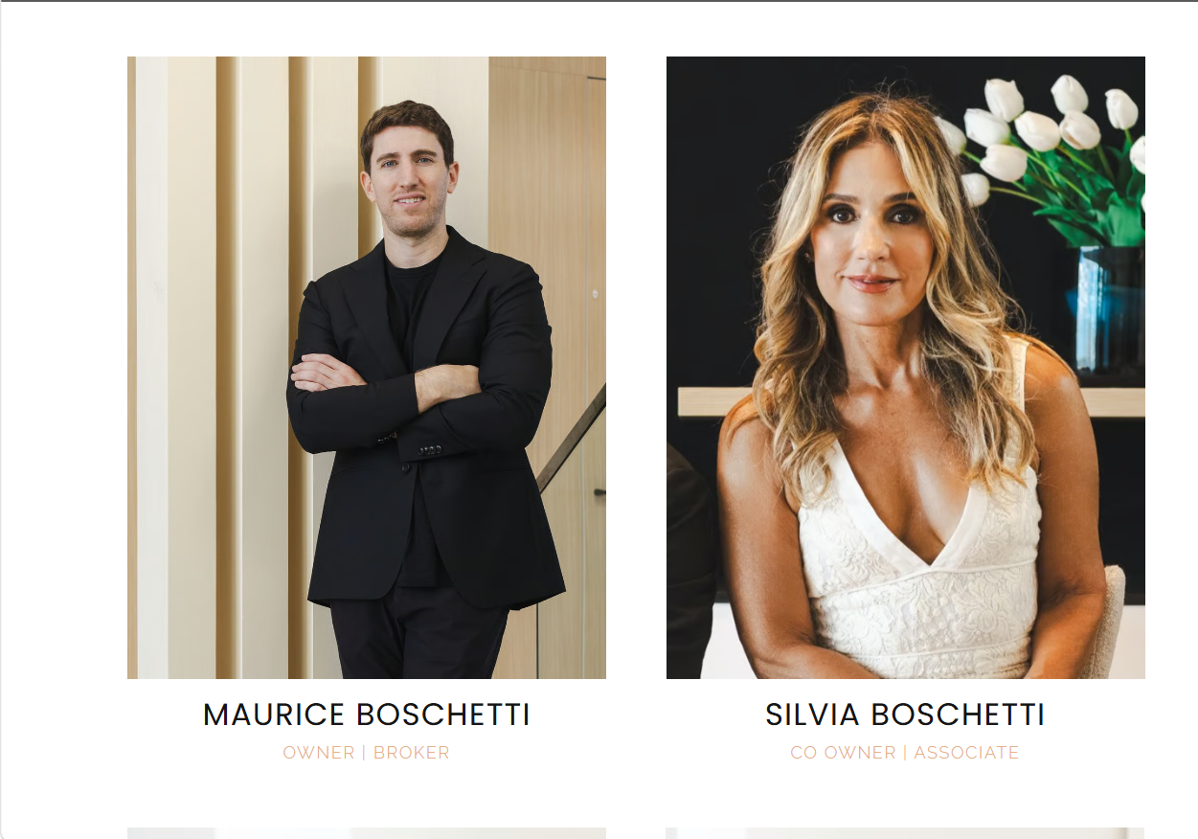
Photo of Lizette P. Benitez Photo of Leo Benitez
Owner founder of The Traffic Law Firm Owner founder of Benitez Law

When you click on the photo, this pops up with our photo
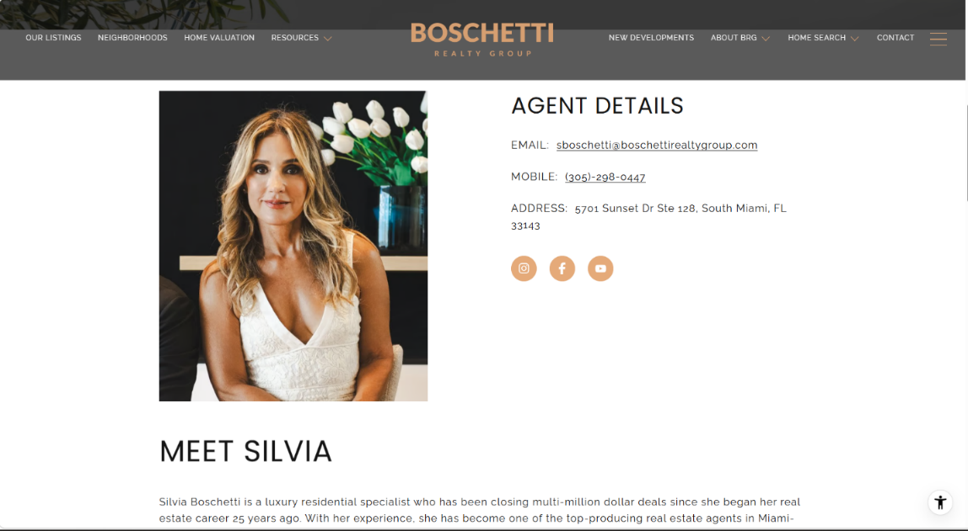

REMOVE ALL OF THIS & CENTER THE PHOTO WITH THE CAPTION UNDERNEATH THAT READS MEET LIZETTE. REMOVE WHAT'S WRITTEN ON THE BOTTOM

LPB BIO
Lizette Benitez is the founder of The Traffic Law Firm and a native of Miami, Florida. With more than three decades of legal experience, Lizette has built her practice on dedication, personal attention, and a strong commitment to fighting for her clients.
Lizette earned her Juris Doctor degree from New England School of Law in Boston, Massachusetts, in 1989. She began her legal career practicing criminal law and, within two years, established her own practice, which has grown into one of Miami’s longest-standing traffic law firms.
Fluent in both English and Spanish, Lizette has earned a reputation for her strategic thinking, strong advocacy, and determination to achieve the best possible results for her clients. Her dedication to her clients has created a legacy of trust that spans generations. Many of the clients she represented early in her career have returned over the years, with their children and grandchildren now seeking her guidance and representation.
Lizette has built The Traffic Law Firm around the belief that every client deserves exceptional service, professionalism, and individualized attention. Her team is committed to making every client feel heard, respected, and confident that their case is in capable hands. No one is treated as just another client, but as family.
Still need to work on this. Suggestions??
Leo’s bio will be sent later.

REVIEWS AND TESTIMONIALS
Any photo of the courthouse or legal photo is good. Video testimonial under photo and reivews under that. Maybe use a drop box?
VIDEO TESTIMONIALS AND WRITTEN REVIEWS FROM GOOGLE AND YELP. You click on which one you want to see or read.
Please refer to Dolan/ Dobrinski/Rosenblum/Blustein website: Florida Personal Injury Attorneys | Dolan Dobrinsky Rosenblum Bluestein, LLP
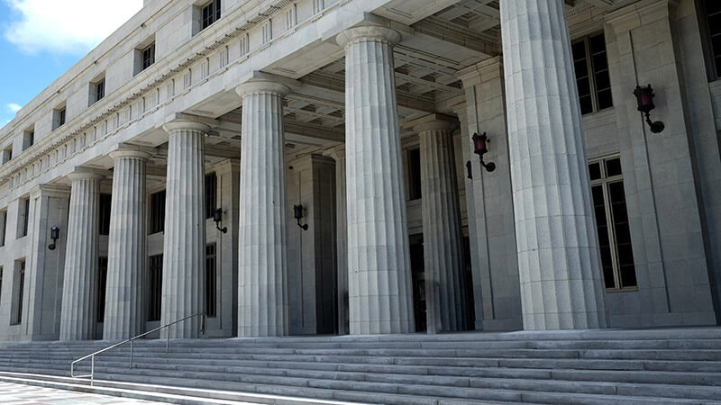


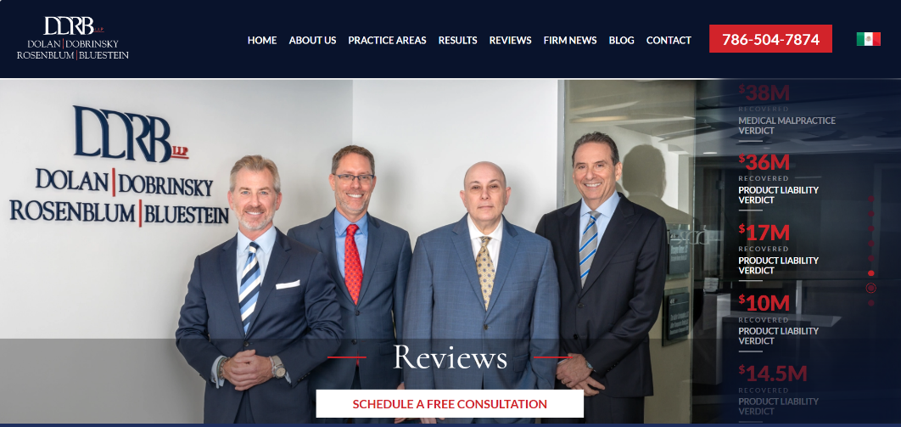
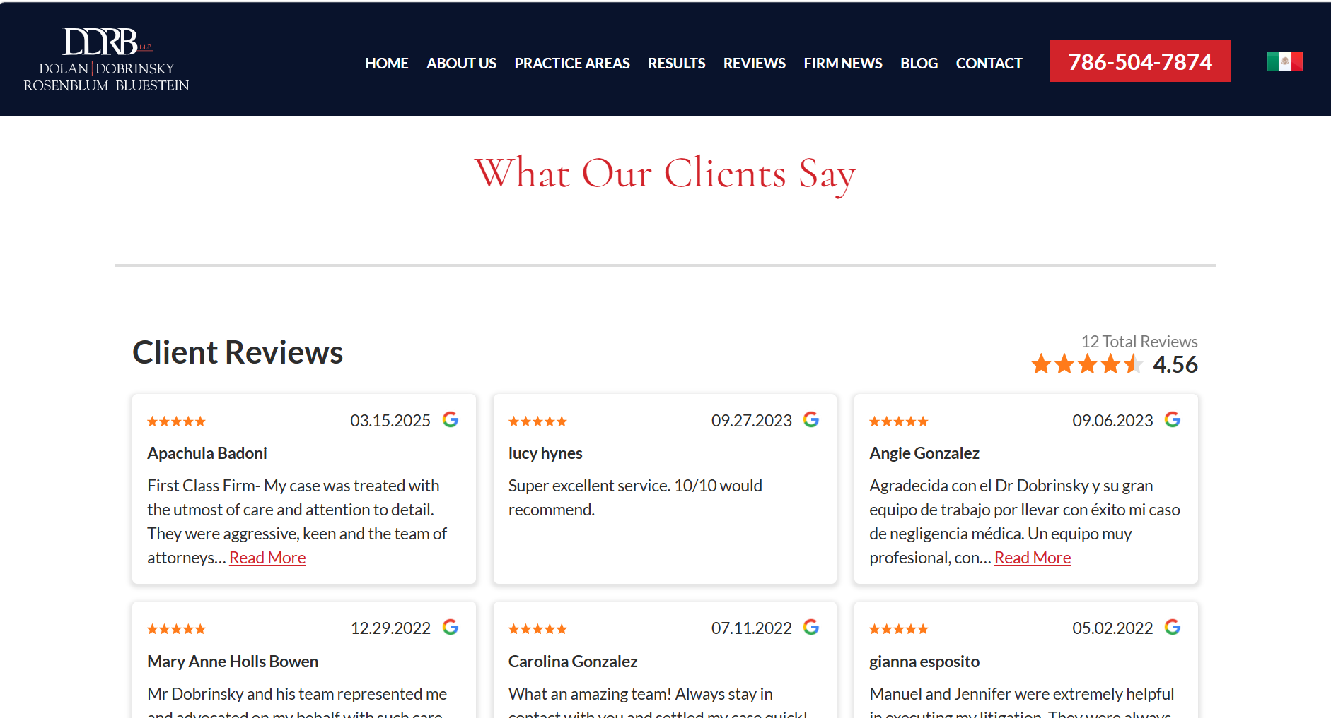

CONTACT US
Please refer to the Boschetti Real Estate Website: See Residential Areas in Florida | Boschetti Realty Group
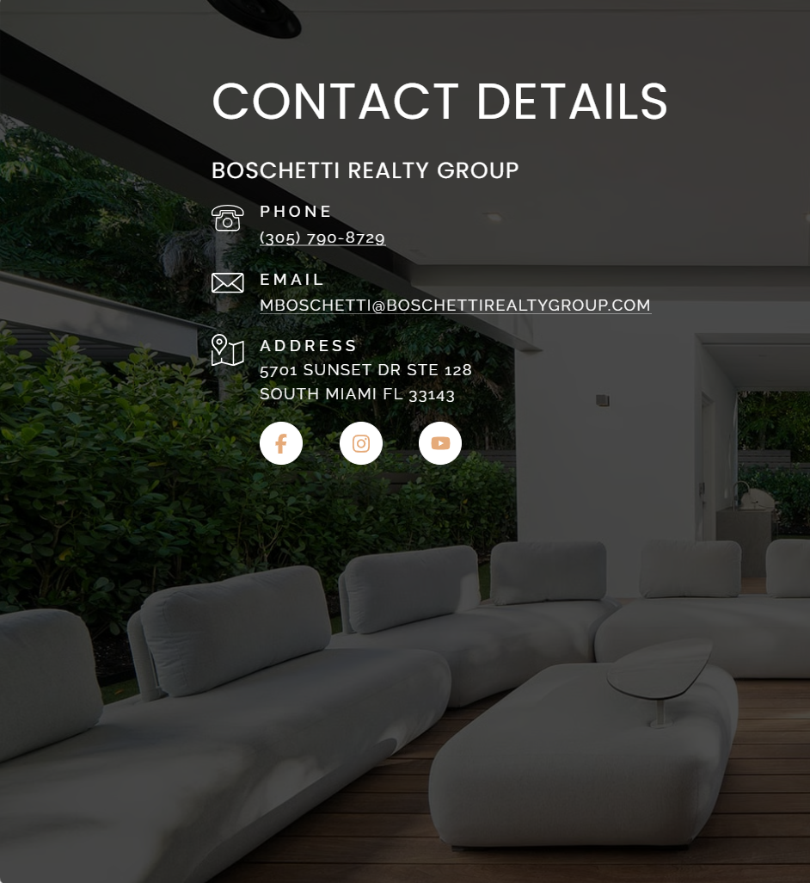
Use the photo below as a background with the CONTACT DETAILS
Please put the TLF logo on her cell phone screen!!!!!
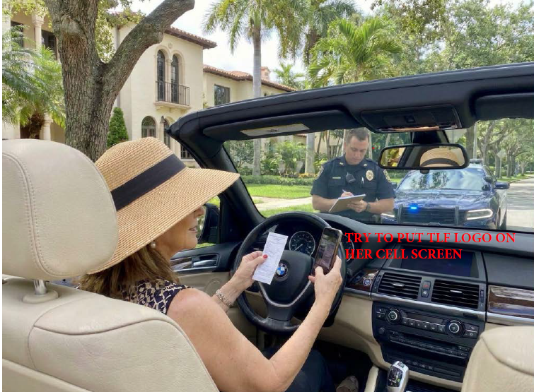
Contact Details
THE TRAFFIC LAW FIRM
(305) 442-0243
THETRAFFICLAWFIRM@GMAIL.COM
122 MINORCA AVENUE CORAL GABLES FL 33134

HIRE US

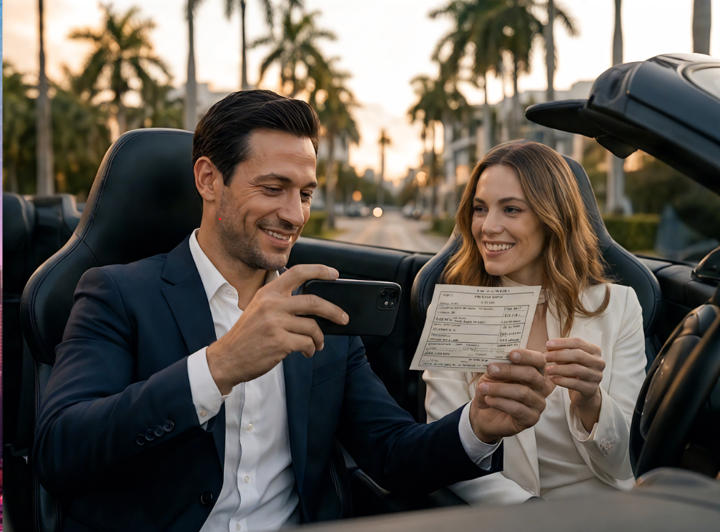

Video of message sent to secretary in the office. Superimpose The Traffic Law Firm in the video of the office with secretary receiving the call from the client.
DROP BOX with ability to hire us.
VIDEO OF SWOPE ON THE TRAFFIC LAW FIRM IN THIS OPTION GOES WELL.

NOTES
COMPANY NAME AND LOGO
I like these color combinations. White background, suggestions?



VIDEO ON HOME PAGE
I want it active (moving highway). Please send me a few options during the daytime. Of the 2 that you sent me, I prefer this one. Or we do a still photo and superimpose the swope with our name… THE TRAFIC LAW FIRM.
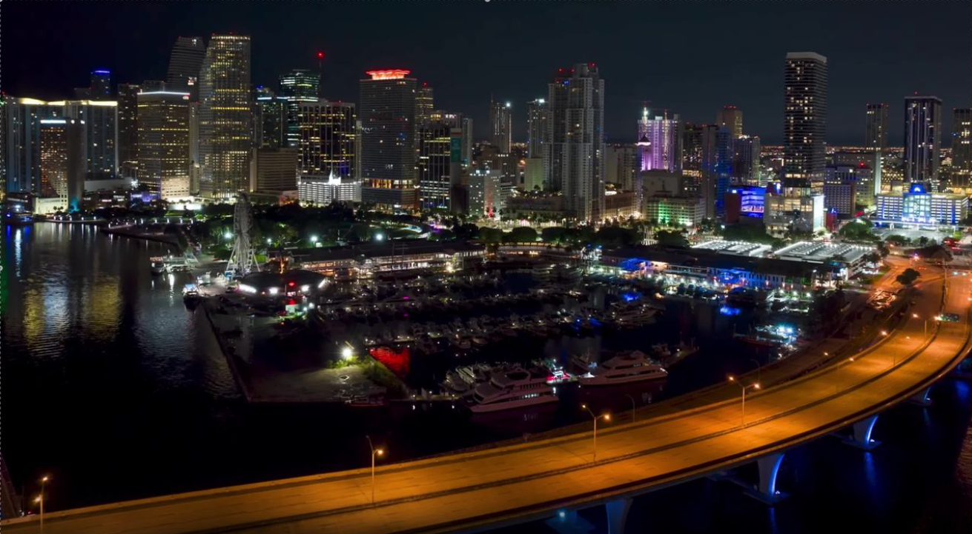
I liked this other photo. Maybe use it somewhere else.
